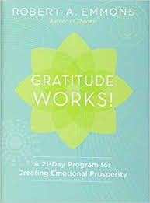

At the heart of the twenty-one-day gratitude challenge is the practice of keeping a gratitude journal. Your journal will become a permanent record that is a gift to yourself and can inspire you to a deeper realization that life is a continual invitation to gratitude. In the pages that follow you will find seven separate sets of exercises, one for each day of the week for the next three weeks. Over the next twenty-one days, the challenge is that you complete each gratitude exercise three different times in your journal. Please try them all, even if you discover that some practices personally work better for you. You’ll want to buy a notebook or journal—it doesn’t have to be fancy—in which to record your entries. Be sure to date and label each entry so that its title matches the one in the exercise; that way you can keep track of your growth and change over time. On the first day, you will follow the instructions for “the three blessings” exercise. You will repeat this exercise on days eight and fifteen. On days two, nine, and sixteen, turn your attention to “to whom for what.” The exercise for days three, ten, and seventeen asks that you focus on the gifts that you have received this day. On days four, eleven, and eighteen, you will select something positive from your life that will be ending in the relatively near future. The fifth exercise (days five, twelve, and nineteen) asks you to think about a positive event or experience and how it might not have occurred in your life. Days six, thirteen, and twenty ask that you compose and deliver a brief gratitude letter to someone in your life. The final exercise (days seven, fourteen, and twenty-one) asks you to “remember the bad.”

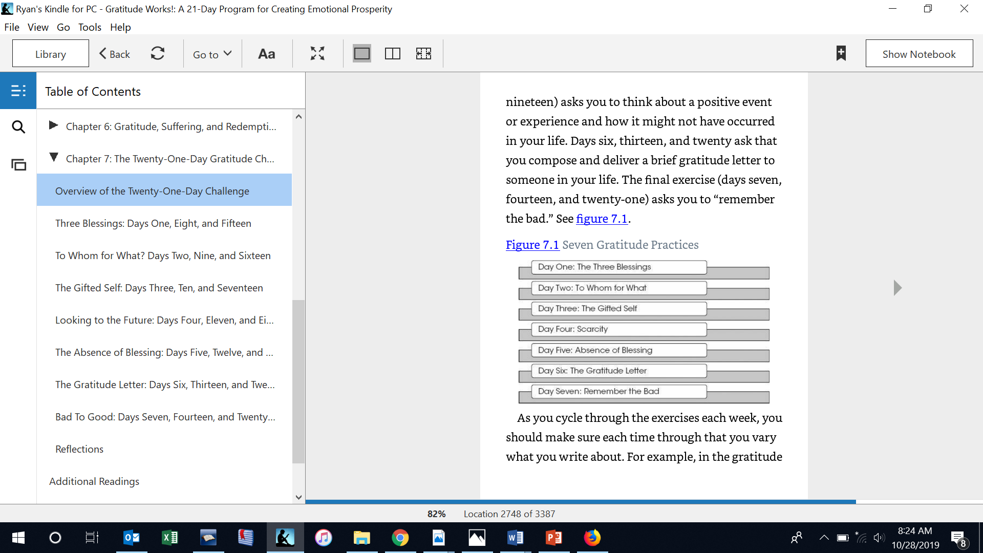

As you cycle through the exercises each week, you should make sure each time through that you vary what you write about. For example, in the gratitude letter, choose three different people on those three days. Each day, set aside a period of about ten minutes to write your journal entry that matches the category for that day. Don’t be too rigid. Take as much time as you need. Even when you don’t think you have anything interesting to say, honor that commitment and write something. Becoming more grateful is an exercise in training one’s mind and training requires practice. You are likely to find that the exercises become easier as you practice them more intentionally and deliberately over the next twenty-one days. You will get better at it! If you need, go back and read the sections of chapters 2 and 3 that are relevant to the assigned exercise for the day. The suggestions that I have given in these chapters and elsewhere should help you. Figure 7.2 graphically shows the pattern to follow in your twenty-one-day journey. Your task is to distribute the entries across the categories so that by the end of the week, you will have explored all the different prompts to enhance gratitude in your life. This particular chart begins the week on a Sunday and ends on a Saturday; you can choose your own beginning and ending days.

FIGURE 7.2

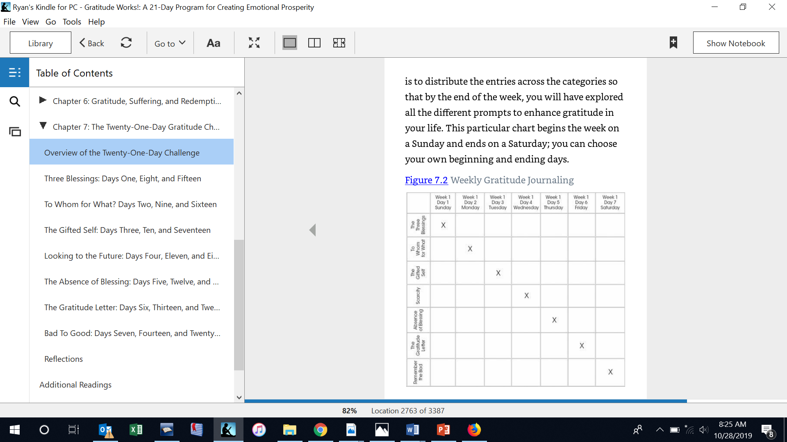

**THREE BLESSINGS: DAYS ONE, EIGHT, AND FIFTEEN**

Spend a few minutes recalling and writing down three good things that happened today for which you could give other people some credit. Someone complimented you on your appearance, a colleague helped you make significant progress on a project that had become bogged down, an old friend whom you had not heard from in years contacted you. These things can be anything that went well, both the big and the small in your life. They do not have to be spectacular or dramatic. It is important to write down why that good thing happened. What enabled the positive event? Why do you think it happened? What does it mean to you? What can you do to make it happen again? Did you tell anyone about the good thing? Write some words down that describe or remind you of the positive experience, then follow up with some reflection on why that particular experience went well. Think of as many reasons as you can. Then think about a second thing that happened today that went well, write it down, and reflect why. Then think about a third good thing, write it down, and reflect why. It is very important for you to write down at least a couple of words on why things went well because it helps you to again experience the good things that happened during your day. Even if these things are small and trivial, such as a smile or enjoying a moment of relaxation, they are good things and that is what is important to focus on. Spend about ten minutes on this exercise.

**TO WHOM FOR WHAT? DAYS TWO, NINE, AND SIXTEEN**

There is a difference between feeling grateful about something and feeling grateful to someone. Brother David Steindl-Rast distinguishes between thankfulness and gratefulness. Thankfulness, for Brother David, is a much more personal experience that occurs when we have benefitted from a specific kindness from another person.2 To say that one is thankful to someone and grateful for something seems to be the more commonly preferred usage. More significant is the fact that thanking and thinking are cognates. To thank originally meant to think of a gift and has come to mean the feeling aroused by these thoughts and their expression in a thankful attitude. When we thank, we think—namely in terms of giver, gift, and receiver. This exercise is designed to stimulate a sense of thankfulness.

Many circumstances or events can elicit thankfulness but it is most often a response to a benefit received from another person or God. In this activity you will focus on those things in your life that you might be grateful or thankful for and the source or provider of these good things. Who has provided you with a benefit? Your spouse? A neighbor? Coworker? One of your students? Your favorite sports team? Think back over the day and write down up to five things for which you are thankful and who provided this gift or benefit to you. You can use this format: ∗∗∗ I am grateful to ___________________________________for _________________________________________________.

**THE GIFTED SELF: DAYS THREE, TEN, AND SEVENTEEN**

In this activity you will focus for a moment on benefits or “gifts” that you have received in your life. These gifts could be simple everyday pleasures, people in your life, personal strengths or talents, moments of natural beauty, or gestures of kindness from others. We might not usually think about these things as gifts, but that is how I want you to think about them. Slowly repeat the word gift or a phrase such as I am gifted or I have been gifted several times. Be aware of your feelings and how you relish and savor this gift in your imagination. Take the time to be aware especially of the depth of your gratitude. Contemplate the value of these gifts and then write them down in your journal. There is a second part to this exercise. Receiving a gift often ignites a desire to reciprocate. Ask yourself the question, “In what ways might I give back to others as an appropriate response for the gratitude I feel?” Be creative. Is there a way that you can pass along the gift to others? Can you “pay it forward”? Who can you tell about this gift you received? Can you perform a nonrandom act of kindness? Offer to pay for the person’s coffee behind you in line, toll for the automobile behind you at the toll plaza, or car behind you in the fast-food drive-thru? Maybe there is an elderly person in your neighborhood who might need assistance with grocery shopping, errands, or other household chores. Put some coins in a meter that is about to expire. Help someone who appears to be lost. Teach a skill to a child. The list is endless. Passing on the gift is the best way to demonstrate gratitude for it.

**LOOKING TO THE FUTURE: DAYS FOUR, ELEVEN, AND EIGHTEEN**

As I have discussed, when people believe that a positive life event is about to end, they are more likely to appreciate it more and make more of an effort to capitalize on the remaining time. A sense of “now or never” can impel us to make the most of every day.

In this exercise, choose an activity, event, experience, or relationship (let’s call it x) that may be ending soon. Keep in mind that you only have a short amount of time left to spend doing x or being with x. Maybe it’s a job that you have, a class that you are taking, a team that you are on, or a place where you are living. This chapter of your life will end soon. Try to select an experience in which you have between one and three months remaining. Given how little time you have left with x, write about why you are grateful for x.

**THE ABSENCE OF BLESSING: DAYS FIVE, TWELVE, AND NINETEEN**

In gratitude, we think about and affirm the good. But there are many ways to think about the good things in our lives and each may not have the same power to kindle grateful feelings. For this exercise, think about how a positive event or experience in your life might never have happened or might never have been part of your life. You can think of this as the “more by less” phenomenon. By taking something away in our minds, we become more aware of benefits that we still have but previously took for granted. Mentally subtracting something good from your life can make you more grateful for it. Think of an aspect of your life for which you feel grateful and then write about the ways in which this might never have happened (e.g., “what would have happened if I had never met my wife?” as opposed to “I am so grateful to have met my wife”). THE GRATITUDE LETTER: DAYS SIX, THIRTEEN, AND TWENTY It is said that feeling gratitude but not expressing it is like wrapping a present and not giving it. For various reasons, we often don’t express gratitude to those who deserve our thanks. We assume they know how much we appreciate them. We felt that they were only doing their job, not realizing that this does not alleviate us of the need to let them know. We planned to but somehow never got around to it. Too much time has passed and we feel embarrassed by our forgetfulness. In this activity, remember a time in your life when you were grateful for something that another person did for you and then write a letter to that person. Was it a teacher, mentor, coach, close personal friend? It is up to you whether you send the letter or not. In the letter, describe specifically why you are grateful to this person, how he or she affected your life, and how often you reflect on his or her efforts. What did he or she do and how does that still affect your life? This should be someone whom you have never properly taken the time to thank and could be a parent, teacher, friend, relative, coach, or someone else. You can compose it using whatever medium (stationary, e-mail, video) that you feel comfortable with.

**THE GRATITUDE LETTER: DAYS SIX, THIRTEEN, AND TWENTY**

It is said that feeling gratitude but not expressing it is like wrapping a present and not giving it. For various reasons, we often don’t express gratitude to those who deserve our thanks. We assume they know how much we appreciate them. We felt that they were only doing their job, not realizing that this does not alleviate us of the need to let them know. We planned to but somehow never got around to it. Too much time has passed and we feel embarrassed by our forgetfulness. In this activity, remember a time in your life when you were grateful for something that another person did for you and then write a letter to that person. Was it a teacher, mentor, coach, close personal friend? It is up to you whether you send the letter or not. In the letter, describe specifically why you are grateful to this person, how he or she affected your life, and how often you reflect on his or her efforts. What did he or she do and how does that still affect your life? This should be someone whom you have never properly taken the time to thank and could be a parent, teacher, friend, relative, coach, or someone else. You can compose it using whatever medium (stationary, e-mail, video) that you feel comfortable with. Spend at least ten to fifteen minutes on this letter. Your letter should be around 250 words. Whether or not you actually send it, imagine how reading the letter will make the recipient feel.

**BAD TO GOOD: DAYS SEVEN, FOURTEEN, AND TWENTY-ONE**

One strategy for cultivating gratitude is to “remember the bad.” Think of your worst moments, your sorrows, your losses, and your sadness and then remember. Focus on how you got through the worst day of your life, the trauma, the trial; you endured the temptation; you survived the bad relationship; you’re making your way out of the dark. Remember the bad things and then look to see where you are now. The seventh daily exercise involves a variation on this strategy. Sometimes even when bad things happen they can ultimately have positive consequences, things we can now be grateful for. Choose an experience from your life that was initially unpleasant and unwanted. Try now to focus on the positive aspects or consequences of this difficult experience. As the result of this event, what kinds of things do you now feel thankful or grateful for? Has this event benefited you as a person? How have you grown? Were there personal strengths that grew out of your experience? How has the event made you better able to meet the challenges of the future? How has the event put your life into perspective? How has the event helped you appreciate the truly important people and things in your life? In sum, how can you be thankful for the beneficial consequences that have resulted from this event? Try to write about three different unpleasant events on days seven, fourteen, and twenty-one.

**REFLECTIONS** Now that you have completed the twenty-one-day challenge, please spend some time reflecting on the following questions. To earn full credit for this assignment you need to 1) Complete the 21 day challenge and 2) Write a 2 page reflection on the overall experience and submit it on Learning Suite. Consider the following questions:

What have you learned about yourself?

Which exercise most resonated with you?

Which exercises were most difficult?

As you took the challenge, what did you find surprising?

What obstacles and roadblocks did you encounter over the twenty-one days?

How did you overcome these obstacles?

Do you plan to continue journaling? Why or why not?

Have you found other journaling practices that have sparked gratitude in you?

Have you shared these practices with anyone?

Do you believe that you have become a more grateful person?